**Code:-**

#include<conio.h>

#include<graphics.h>

#include<dos.h>

//navy day info

char text[]="\n \n \n \n \n\n \n \n \n \n \n  \t Navy Day was celebrated on the east coast last year. This year, the\n celebrations will be organised on the west coast. The venue has been chosen\n carefully and the Sindhudurg Fort meets the navy's requirements to  conduct\n an operational demonstration of its frontline assets. It also has rich mari-\n-time history.\n \t\t\tThis December 4 Navy Day celebrations will be held at\n the iconic Sindhudurg Fort in the presence of President Srimati Droupadi Murmu and PM Shri Narendra Modi. 70 fighter ships will participate in the celebrations";

void delay();

void textdata();

int main() {

    int gd = DETECT, gm,i,x1,y1,x2,y2;

    int polygon[] = {40, 242, 90, 330, 300, 330, 310, 345, 330, 345, 330, 330, 340, 330, 350, 340, 365, 340, 365, 330, 380, 330, 390, 344, 400, 344, 415, 335, 425, 335, 432, 340, 438, 340, 443, 345, 480, 345, 520, 242, 515, 242, 512, 238, 490, 238, 488, 241, 484, 241, 478, 225, 463, 225, 460, 230, 457, 230, 457, 243, 446, 243, 446, 258, 426, 258, 420, 220, 410, 220, 404, 182,394,182,388, 148, 378, 148, 374, 124, 350, 124, 340, 148, 325, 148, 315, 182, 300, 182, 290, 220, 250, 220, 240, 230, 235, 230, 235, 220, 230, 215, 215, 215, 210, 220, 210, 230, 180, 230, 175, 235, 135, 235, 135, 238, 175, 238, 175, 242, 150, 242, 40, 242};

    clrscr();

    initgraph(&gd, &gm, "c://TURBOC3/bgi");

    textdata();

//akash

    setcolor(9);

    setfillstyle(1,9);

    rectangle(0,0,600,480);

    floodfill(1,251,1);

//samudra

    setcolor(1);

    setfillstyle(1,1);

    rectangle(0,250,650,480);

    floodfill(1,251,1);

//killa

    setcolor(7);

    setfillstyle(9,7);

    rectangle(550,245,650,250);

    rectangle(550,242,557,245);

    floodfill(551,243,7);

    floodfill(551,246,7);

//sindhudurg  text

    setcolor(4);

    line(520,150,600,235);

    line(585,230,600,235);

    line(605,225,600,235);

    settextstyle(DEFAULT_FONT,HORIZ_DIR,1);

    outtextxy(470,135,"Sindhudurg Fort");

//sun

    setcolor(14);

    setfillstyle(1,14);

    circle(75,50,20);

    floodfill(76,51,14);

//ship body polygon

    setcolor(8);

    setfillstyle(1,8);

    fillpoly(sizeof(polygon)/sizeof(polygon[0]) / 2, polygon);

//red flag lines

    line(501,210,501,238);//middleflag

    line(510,220,510,238);//leftflag

    line(491,220,491,238);//rightflag

    line(270,220,270,182);

    line(362,124,362,70);

    line(213,218,170,218);

//ship brown box

    setcolor(6);

    rectangle(265,177,275,181);

    setfillstyle(SOLID_FILL,6);

    floodfill(266,178,6);

    rectangle(255,200,260,219);

    setfillstyle(SOLID_FILL,6);

    floodfill(256,201,6);

    rectangle(280,200,285,219);

    setfillstyle(SOLID_FILL,6);

    floodfill(281,201,6);

//ship indian flag

    setcolor(12);

    rectangle(362,70,382,74);//f4

    setfillstyle(SOLID_FILL,12);

    floodfill(363,71,12);

    setcolor(10);

    rectangle(362,78,382,82);//f4

    setfillstyle(SOLID_FILL,10);

    floodfill(363,79,10);

    setcolor(15);

    rectangle(362,74,382,78);

    setfillstyle(SOLID_FILL,15);

    floodfill(363,75,15);

    setcolor(1);

    circle(372,76,2);

    line(372,74,372,78);

    line(370,76,374,76);

//red flags

    setcolor(4);

    rectangle(501,210,511,215);//F1

    setfillstyle(SOLID_FILL,4);

    floodfill(502,211,4);

    rectangle(510,220,516,225);//F2

    setfillstyle(SOLID_FILL,4);

    floodfill(511,221,4);

    rectangle(491,220,497,225);//F3

    setfillstyle(SOLID_FILL,4);

    floodfill(492,221,4);

//indian navy ribbon

    setcolor(4);

    rectangle(90,290,480,305);

    setfillstyle(SOLID_FILL,4);

    floodfill(91,291,4);

    setcolor(14);

    line(90,292,480,292);

    line(90,303,480,303);

    settextstyle(DEFAULT_FONT,HORIZ_DIR,1);

    outtextxy(200,295,"INDIAN NAVY");

    getch();

    cleardevice();

//last page

    settextstyle(3,HORIZ_DIR,6);

    outtextxy(230,200,"Thank You!");

    getch();

    closegraph();

    return 0;

}

void delay(unsigned int mseconds) {

    int  goal;

    goal = mseconds + clock();

    while (goal > clock());

}

void textdata()

{

    int i;

//indian color stripes

    setcolor(12);

    rectangle(0,0,5,640);

    setfillstyle(SOLID_FILL,12);

    floodfill(1,1,12);

    setcolor(15);

    rectangle(5,0,10,640);

    setfillstyle(SOLID_FILL,15);

    floodfill(6,1,15);

    setcolor(10);

    rectangle(10,0,15,640);

    setfillstyle(SOLID_FILL,10);

    floodfill(11,1,10);

//text first page

for(i=0;i<160;i++)

{

    setcolor(15);

    settextstyle(1,HORIZ_DIR,3);

    outtextxy(90,100,"On the 4th of December..");

}

for(i=0;i<260;i++)

{

    setcolor(15);

    settextstyle(1,HORIZ_DIR,3);

    outtextxy(95,145,"We are celebrating..");

}

for(i=0;i<310;i++)

{

    setcolor(15);

    settextstyle(1,HORIZ_DIR,3);

    outtextxy(95,190,"the 52th Navy Day ...");

}

for(i=0;i<290;i++)

{

    setcolor(15);

    settextstyle(1,HORIZ_DIR,3);

    outtextxy(95,241,"on our");

    settextstyle(1,HORIZ_DIR,4);

    setcolor(14);

    outtextxy(195,235,"Sindhudurg Fort");

}

for(i=0;i<290;i++)

{

    setcolor(15);

    settextstyle(1,HORIZ_DIR,3);

    outtextxy(95,295,"with the presence of");

}

for(i=0;i<340;i++)

{

    settextstyle(1,HORIZ_DIR,4);

    setcolor(14);

    outtextxy(90,340,"Narendra Modi & Draupadi Murmu.");

}

cleardevice();

//second page

//flag india right

    setcolor(12);

    rectangle(362,70,402,80);//f4

    setfillstyle(SOLID_FILL,12);

    floodfill(363,71,12);

    setcolor(10);

    rectangle(362,90,402,100);//f4

    setfillstyle(SOLID_FILL,10);

    floodfill(363,91,10);

    setcolor(15);

    rectangle(362,80,402,90);

    setfillstyle(SOLID_FILL,15);

    floodfill(363,81,15);

    setcolor(1);

    circle(382,85,5);

    line(377,85,387,85);

    line(379,82,387,87);

    line(379,87,387,82);

    line(382,80,382,90);

    setcolor(6);

    setfillstyle(1,6);

    rectangle(358,70,361,120);

    floodfill(359,71,6);

    setcolor(14) ;

    ellipse(360,70,0,180,2,3);

//flag india left

    setcolor(12);

    rectangle(262,70,302,80);//f4

    setfillstyle(SOLID_FILL,12);

    floodfill(263,71,12);

    setcolor(10);

    rectangle(262,90,302,100);//f4

    setfillstyle(SOLID_FILL,10);

    floodfill(263,91,10);

    setcolor(15);

    rectangle(262,80,302,90);

    setfillstyle(SOLID_FILL,15);

    floodfill(263,81,15);

    setcolor(1);

    circle(282,85,5);

    line(277,85,287,85);

    line(279,82,287,87);

    line(279,87,287,82);

    line(282,80,282,90);

    setcolor(6);

    setfillstyle(1,6);

    rectangle(302,70,305,120);

    floodfill(303,71,6);

    setcolor(14) ;

    ellipse(303,70,0,180,2,3);

    setcolor(12);

    settextstyle(DEFAULT_FONT,HORIZ_DIR,1);

    outtextxy(297,140,"Jay Hind!");

//paragraph text effect

for(i = 0; text[i] != '\0'; i++)

    {

    putchar(text[i]);

    delay(0

);

    }

//message

for(i=0;i<195;i++)

{

setcolor(14);

settextstyle(1,HORIZ_DIR,3);

outtextxy(150,330,"This event is very important");

outtextxy(170,360,"and proud moment for us.");

}

for(i=0;i<390;i++)

{

outtextxy(40,390,"That's why we dedicate our project for this event.");

outtextxy(240,420,"Wishing you...");

}

cleardevice();

//wishes page 3

for(i=0;i<300;i++)

{

setcolor(12);

settextstyle(1,HORIZ_DIR,15);

outtextxy(130,10,"HAPPY");

}

for(i=0;i<500;i++)

{

setcolor(15);

outtextxy(170,150,"NAVY");

}

for(i=0;i<500;i++)

{

setcolor(10);

outtextxy(200,300,"DAY");

}

}

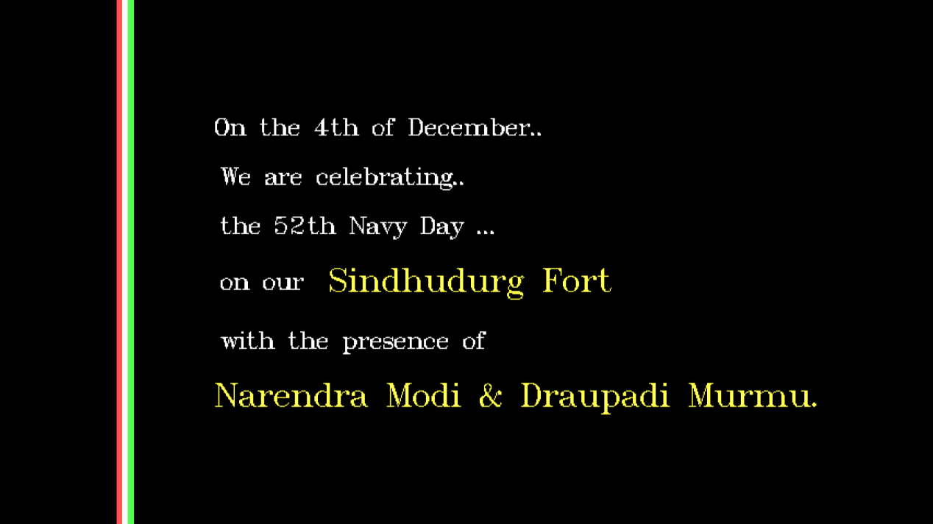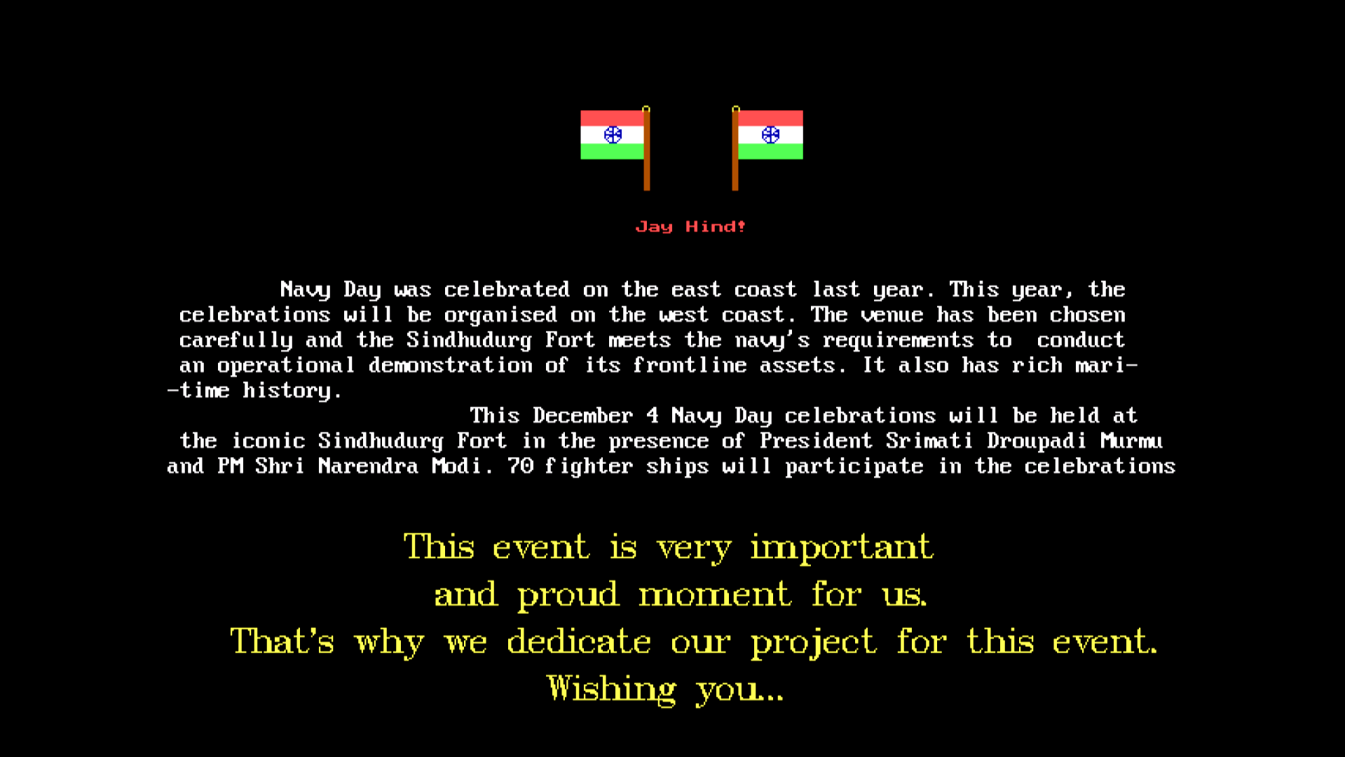**Output:-**

Page 2

Page 1

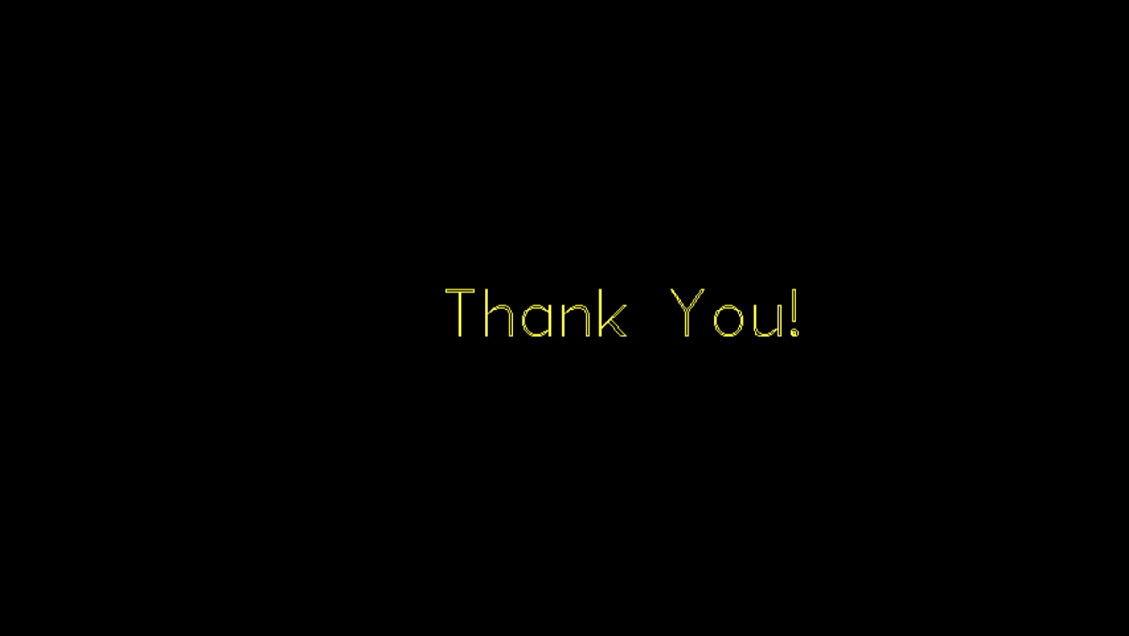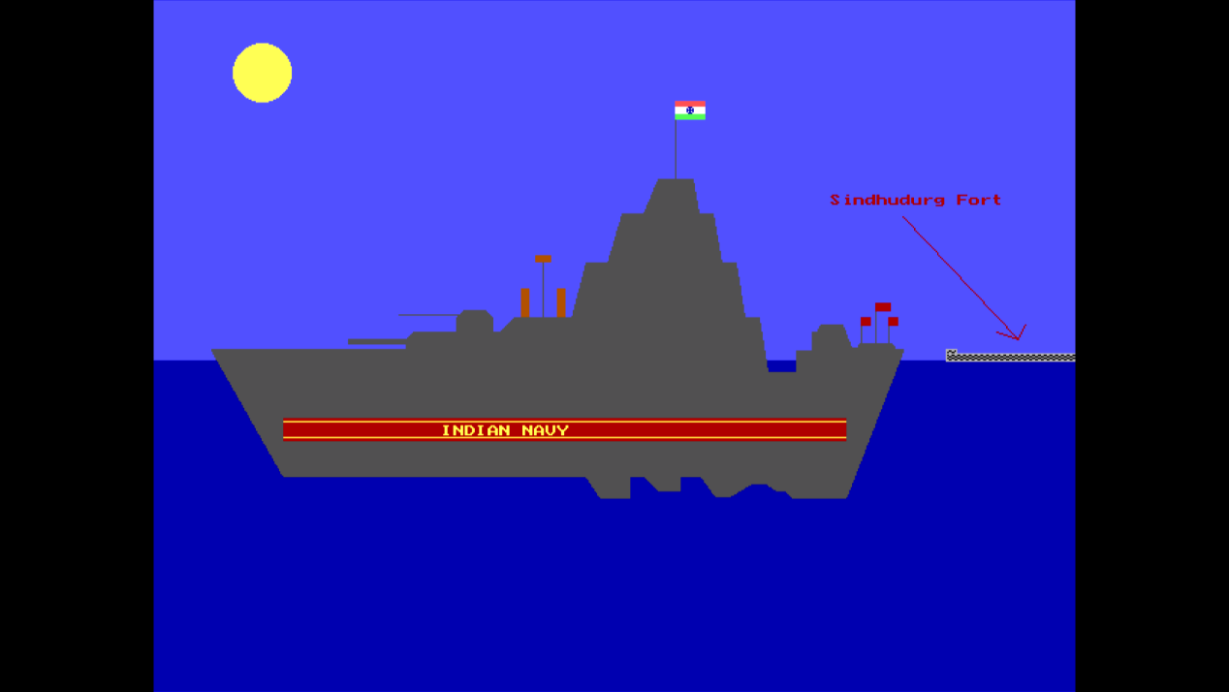

Page 3

Page 5

Page 4